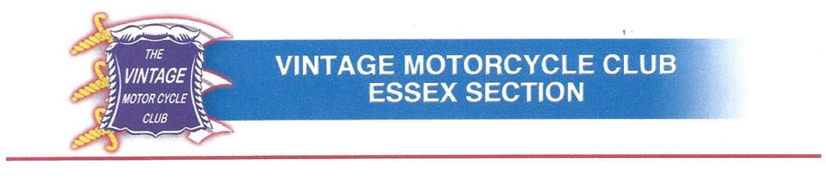
Agenda for section AGM 14th January 2026

- Section President to officially open the meeting – then pass to the Chairman for his yearly report
- Chairman to present his yearly report and then pass to the Treasurer to present the section accounts
- Treasurer to go through the accounts and ask for any questions and then propose them to be adopted
- Chairman to comment on any other business related to 2025/2026
- President to close this element
- Chairman, to ask Secretary if there are proposals for a replacement.
- Current Secretary to respond with new candidates for open positions of Chairman and Secretary.
- Treasurer and Secretary to officially stand down
- Votes taken on new candidates for open positions
- New Chairman to confirm that David Smith, and Dave Coatsworth are happy to serve again as committee members
- Proposals taken for any other new committee members
- Vote taken on new and re-proposed existing members
- New Chairman welcome everyone and ask if there is any other business
- New Chairman to close the meeting

